# C:\Users\angel\AppData\Local\Microsoft\Windows\INetCache\Content.Word\Inncee-logo.jpg

# How to install Inncee’s tracking script in your Shopify Store

To allow us to begin tracking your visitor activity in your store, we’ll need you to embed our tracking script file in your theme. By placing it near the top of the <head> tags in your theme file, it will help us to accuratly track when a visitor takes an action in your store.

Follow the steps below to begin your installation.

1) Log in to your shopify store’s admin panel

2) Click on the “Online Store” > “Themes” in your main menu

3) Click on the Three Dots icon to open up the menu, and click on the “Edit HTML/CSS” link

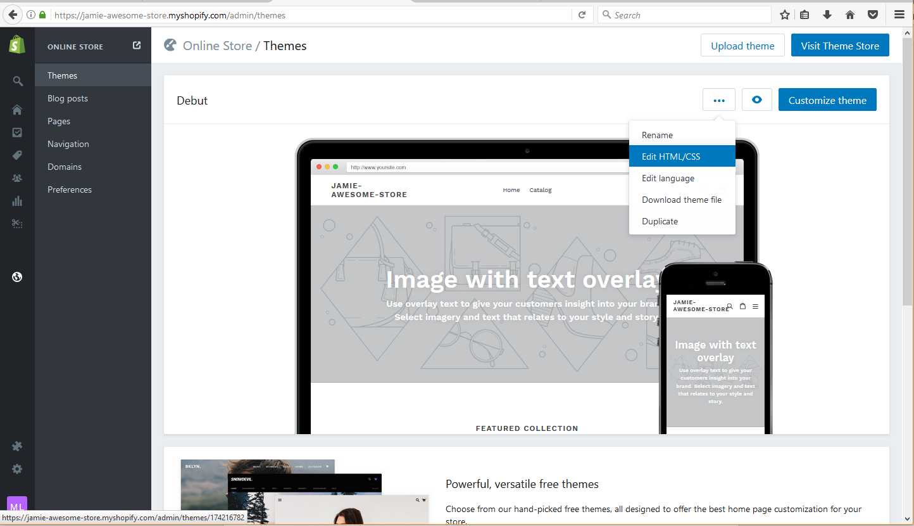

4) Select the “theme.liquid” file under your “Layout” folder to load it up on your screen. In the “theme.liquid” file, you should be able see the <head> tag near the top of the file.

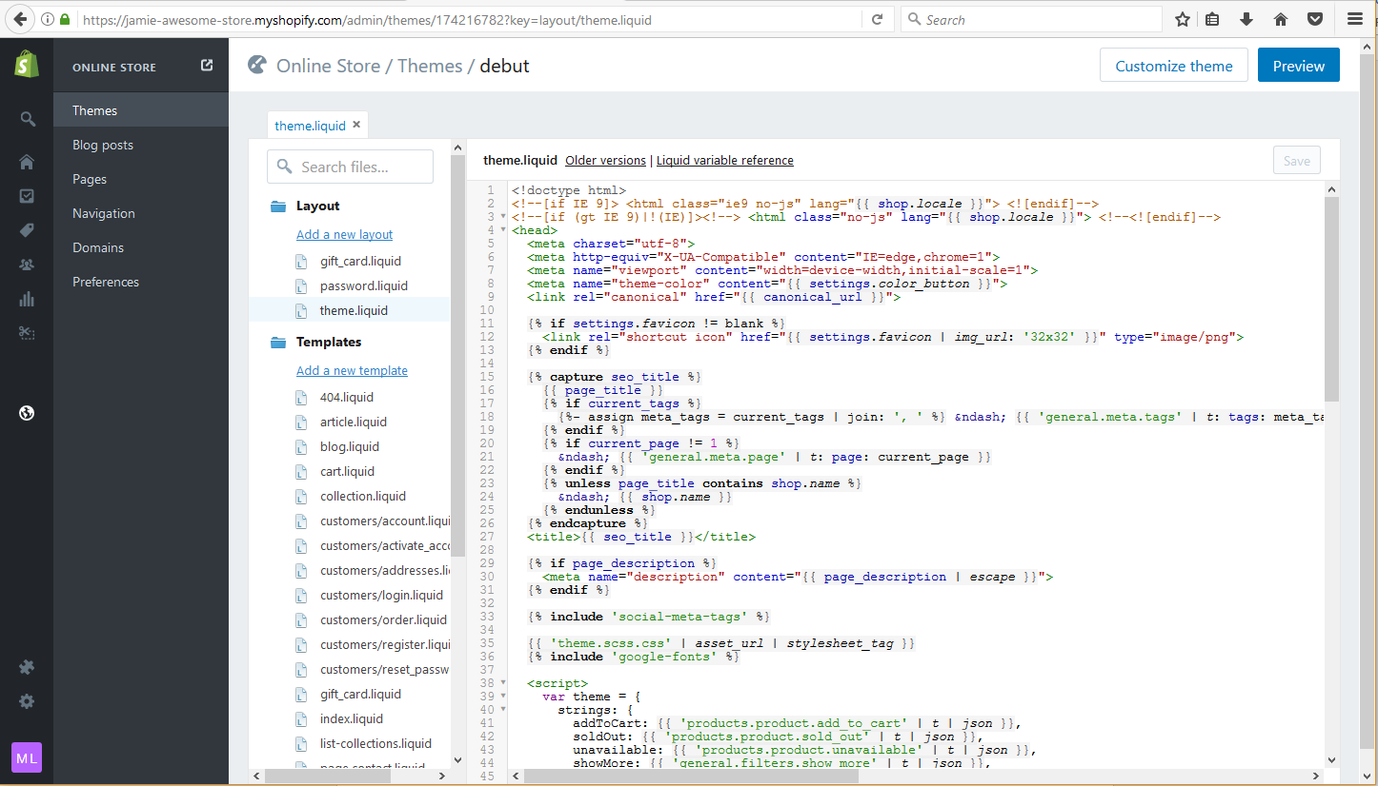

5) Paste the your script file codes after the the <title> tags (you should find them a couple of lines down from the <head> tag) Please make sure that you code is pasted only after the closing </title> tag.

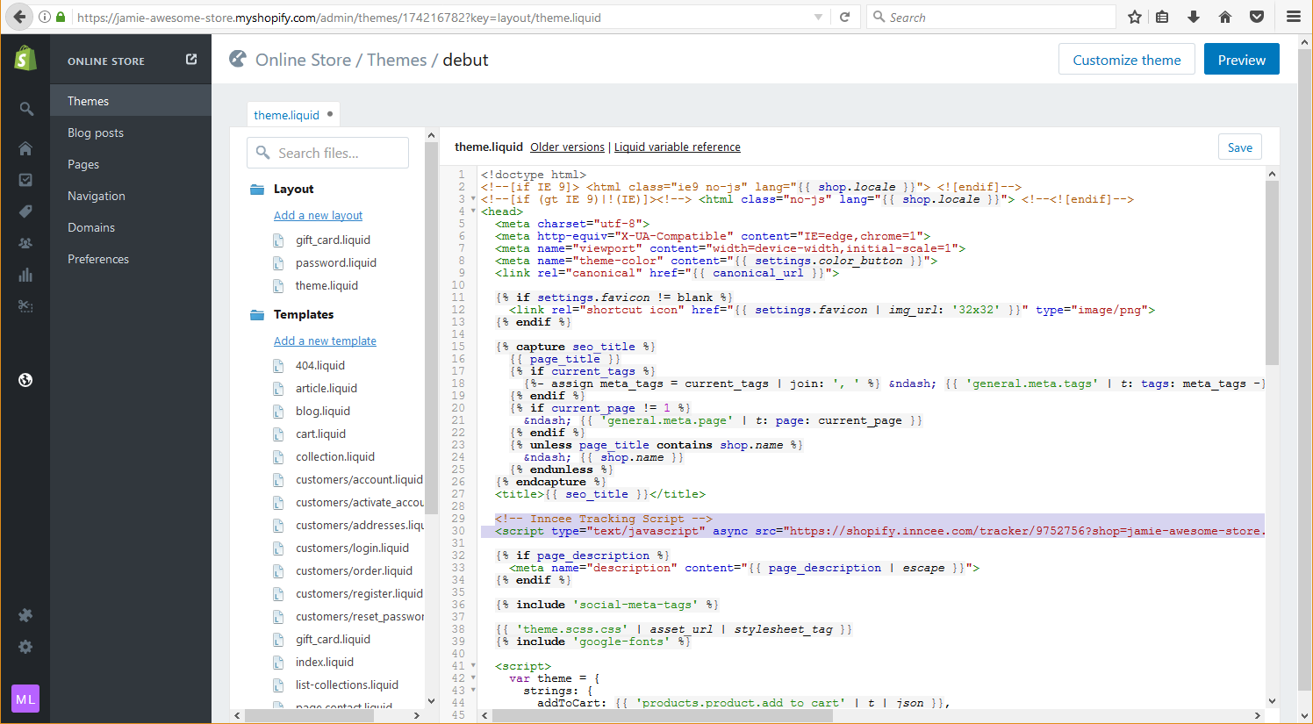

**Paste your tracking script here, just below the <title> tags**

6) Click the “Save” button and you’re done!